Issues/questions for QMFM WS(6) November 18-25, 2024 (Nov.16)

- Filter issues
Filtering in relation to Historic tuning (incl. when observations are missing): how the filter estimates trend (and gap), and how it uses shocks (SD imposed vs observed)—with and without tuning. What is the impact or implication of missing observations—with and without tuning?
- Forecast issues
Producing forecast errors (and fan charts). We would like to include forecast errors (and variance decomposition, FEVD-FESTD) in reportForecast (e.g., in a table) and fan charts, at least for key variables.
The guidance so far (and Forecast_error_calcSI.m, used only in WS Dec2022, still in codes/misc) derives the confidence interval of one SD around point-estimated forecast for each period.
While we understand that the distribution of each forecast variable depends on the (calibrated or model) SD of all relevant shocks, we need to better understand how exactly the FEVD function generates the SD of the forecast variable, via the SD and contributions of each shock and how to interpret its arguments.
See further the illustration of our query in Annex below.
Forecast anticipated shocks. Notice a change in ZR’s Baseline of Sept 11, line 70, it had:
pln = Plan.forModel(m, rngFcast, "anticipate",true). whereas we have so far used:
pln = Plan.forModel(m, rngFcast). We are not sure if/how this matters.
In our current Baseline tuning, are shocks anticipated?
- Bayesian estimation
While the explanation of the theory is clear from the handout (Set II, Handout 5), what has been less clear for us is the practical application including the use of simulations (varying the parameter value using the prior distribution). We would benefit from a lot more guidance on the latter, including on the use of codes/estim/… for the estimation of selected parameters.
- Model infrastructure
Options. We would benefit from a revisiting of the use of “options”, now the infrastructure is complete, including the Dec2023/Jan2024 streamlining and the use of process.options in the codes/utils directory (as well as the main other codes in utils).
- Model specs and tuning in relation to Sept 2024 forecast
Doubtful NA final demand figures recent Q. Are we right in suppressing all final demands but gcons? Even gcons in NA (which we assume includes 25% of Budget capital spending) may be off.
Govt demand gap & gdem as ratio of GDP. To derive the l_gdem_gap (implicitly!), we multiply the ratio with GDP, implying non-linearity of model. How can we best explain the “linearization error” (e.g., in decomposition chart)?
More importantly, our model has behavior relations for gdem_y, i.e., in % of GDP, which drive the level of govt demand and hence output (gaps). As we need to multiply by output (line 576), this seems to create pro-cyclical-ity, as absolute govt spending per se rises in the upturn due to the multiplication. (Separately, the gdem_y ratio will go down a bit thanks to our cyclical component, gdem_y_cyc).
Fiscal tuning. The possible need for tuning (beyond PCI FISCAL projection thru 2025/26). Currently, after PCI the fiscal variables start returning to chosen sustainable ratios ("steady states") (for deficit excl. grants 7.5 ( o/w new borrowing 5%, grants 2.5%), revenue 24%, gdem G&S 26%, and oexp 5%.
But as revenue is still far from its sustainable ratio, and expenditures immediately rise above PCI-restricted levels after PCI, so does the deficit rise above its 2025/26 and sustainable levels, before returning gradually to its sustainable ratio.
Exchange rate forecast. Shouldn’t the exchange rate adjust faster in line with the target depreciation rate? (model l. 775-88)? Now, the rate of depreciation remains high for too long.
Our ER rule implies that the target ER change responds positively to the (currently projected negative) CPI deviation from target CPI; and negatively to the (currently projected positive) RER gap, thus slowing down the move to the target depreciation as determined by inflation differential with trading partners. Hence the changes we made in Baseline tune:
m.e5 = 0.1; % was 0.30 (as BNR) but we need lower ER response to inflation deviation
m.e6 = 0.95; % was 0.85 (as BNR) but we need a higher ER response to RER gap.
(Our persistence parameter is already 0, so we cannot make the adjustment faster.)
GDP discrepancy term (“shock”, but not shock!) in GDP equation summing final demands. Earlier in model development (Set I, Handout 2), we thought we needed inventories as an equilibrating term. Yet (change in) inventories are included in private investment. The discrepancy shock is only needed because we sum gaps with constant weights:
l_y_gap = w_y_cons * l_cons_gap + w_y_inv * l_inv_gap + w_y_gdem * l_gdem_gap + w_y_exp * l_exp_gap - w_y_imp * l_imp_gap + shock_l_y_gap
See also sum of trends, line 818 minecofin.model), which has no shock, as it is a definition.
Weights of final demand in GDP. Is there a need for updating?
Foreign RIR trend. Should we change ss_rstar_tnd ? (currently zero) as world interest rates are up, as is our dbObs.obs_rstar_tnd = hpf(100*log(1+db.rstar_US_cbo/100))
Money demand. Our projection of money demand (auxiliary variable) is based on a real money demand as a positive function of the nominal interest rate (in deviation from its trend). However, the money block (Set II, handout 4) has real money demand (gap) as a negative function of the RIR (gap) (and the 2020 NBR/IMF paper has it as a negative function of the change in RIR trend).

Annex: Example of Variance Decomposition (VD) and Forecast Error VD
We understand that (forecast error) variance decomposition consists of the absolute contributions of the shocks that determine the variance of the variable under study, e.g., l_rp_cpi_ener_gap.
--Is the variance of l_rp_cpi_ener_gap{t}, projected for each period {t}, a function of the SD of the shocks, and analytically derived? (i.e., not from simulation by drawing the shocks from their distributions)?
--Is this different for the VD in modelReport than for our FEVD example in Forecast_Error_calc (Dec 2022)
We understand that the blue line shows the SD of l_rp_cpi_ener_gap estimated from the data, and the orange line is the projected SD calculated from the model SD of all shocks (model-based cumulative asymptotic standard shocks).
--Does the orange line represent cumulative shocks for all shocks (affecting the variable) or only the cumulative shocks specific to the variable?
--How to understand intuitively that the orange line stops increasing, typically from t=15?
--What to do if the initial and/or final (say t=20) difference between data- and model-based SD is large?
--Why is the initial model-based SD typically lower than the data-based SD, then rises above it (for most variables in our model)?
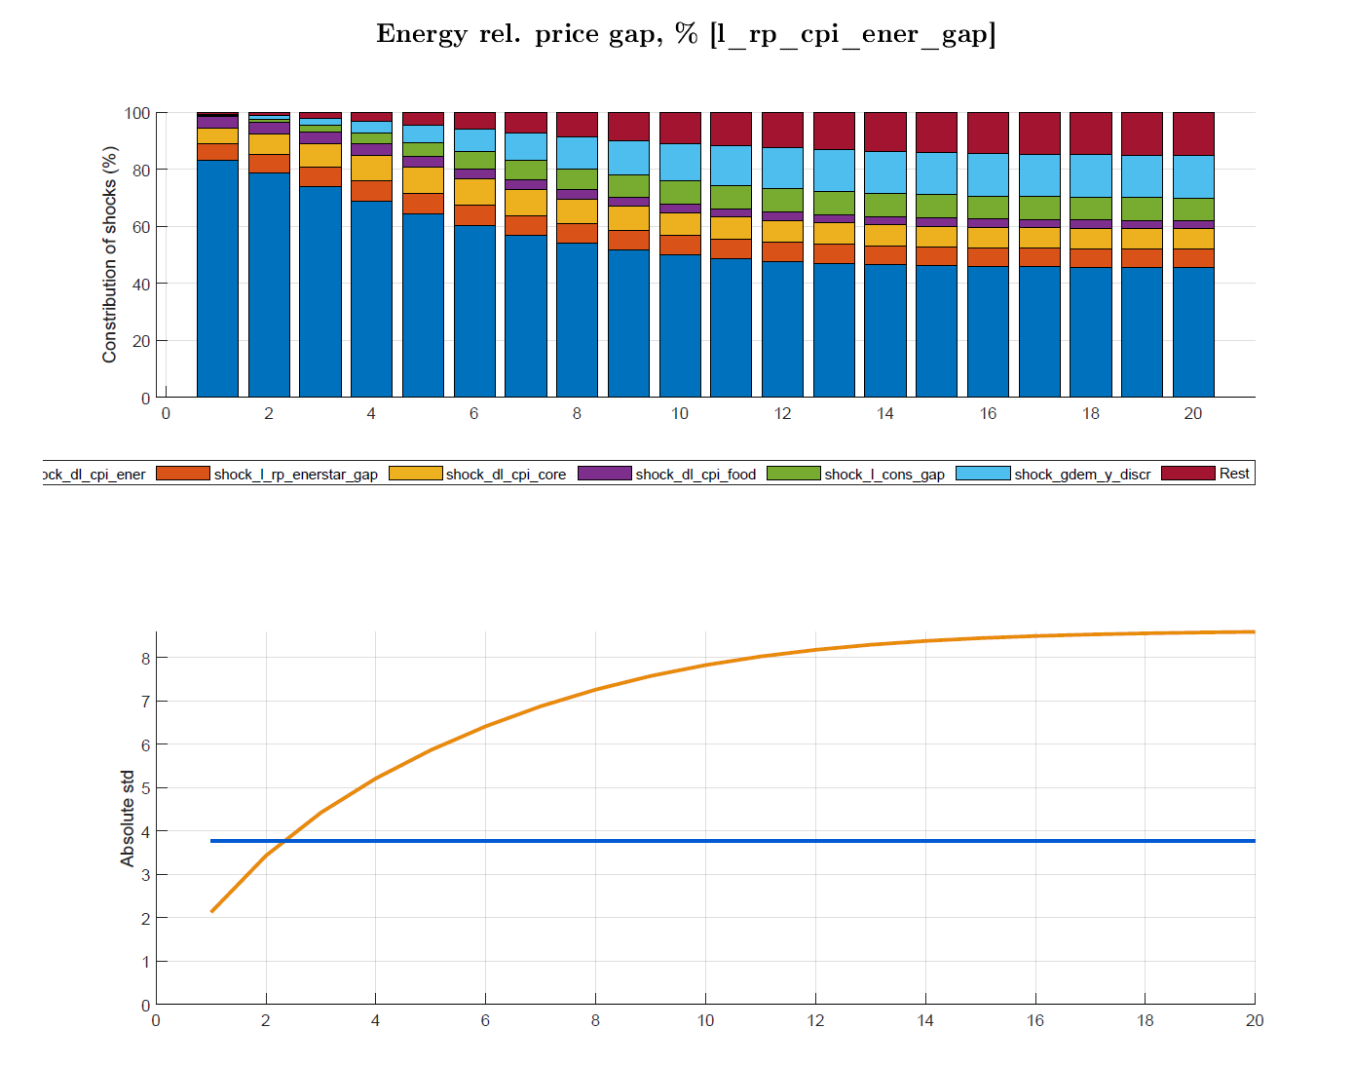

Similarly for the CPI as weighted sum of CPI components, l. 721.

